
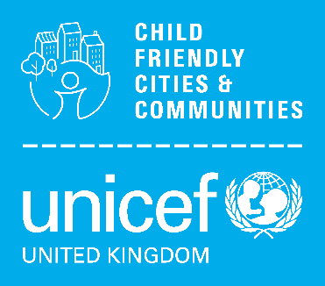
(For completed workstreams
please use the Impact assessment template)

Instruction – easy guide

Complete or working towards Nottingham becoming an accredited CFC

E.g. involvement of C&YP in decision making….

End – instruction … please email completed document to child.friendly@nottinghamcity.gov.uk

Title:
Event or workstream update
Date briefing submitted:
Background and context:
The purpose and why
Including badge and outcome below
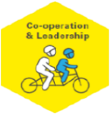
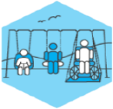


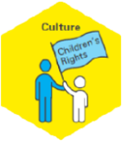
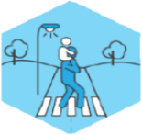

Nottingham’s CFC Badge(s):

Equal and Included
Education and
Learning
Safe and Secure
Healthy
- Safe and Secure
- Healthy
- Education and Learning
- Culture
- Co-operation and Leadership
- Communication
Outcome:
From Nottingham’s Action Plan
Event detail / Workstream update:
The how, what and when..?

- What has happened / is happening?
- Who was / is involved?
- What was / is in scope and why?
- What engagement has / is taken / taking place?
- Was it or is it successful?

Learning to date:
If applicable
Next Steps:
If applicable
Equal and Included is a Golden Thread
Please specify demographics, priority or under-represented groups relevant to the briefing

Consider the 7 principles of a Child Rights-Based Approach (details below).
Please write how and why the topic of your briefing demonstrates which of the principles in practice.
Dignity
Participation

Life, Survival & Development

Non-discrimination

Transparency & Accountability

Best Interests
Interdependence & Indivisibility

